**Computer Systems – COS10004 – SEMESTER 2 2022**

**Assignment 2**

**Mohamed Shafi Uzman Fassy (102608927)**

**LAB SESSION – WEDNESDAY 10:30 AM**

Assignment 2 Mastermind game code in **stage 1** consists getting user entered string such as name and storing it in a block while **stage 2** uses a function called **getcode** that contains nested functions such as loopCode , wrongCode and testCode which will take in the entered code and loop only if the correct code has not been entered as it has to follow the instructed pattern of “R B G Y P C” and **stage 3** combines **stage 1** and **stage 2** to test the program works in collecting codemakers and codebreakers name and the number of guesses. **Stage 4** is coded to take in the codebreakers guesses based upon the maximum number of guesses which have been allowed by the gamemaker with the used of the loopQuery function. **Stage 5-part A** uses the function **comparecodes** to compare the position and colors while **Stage 5-part B** uses basic logic to output the final scenario of when the code is matching and outputting if the gamebreaker has won or lose and if the game is over.

Assumptions:

1. Used many loop functions.
2. Might have not followed properly ABI conversion methods.
3. Using the same registers to display messages.

Unsolved Problems with the program:

1. I could not find why at the end of the game the codebreakers name does not display properly when they win or lose.
2. I could not do the bonus stage 6 for assignment 2.

Stage 1:

Stage 2:

Stage 3:

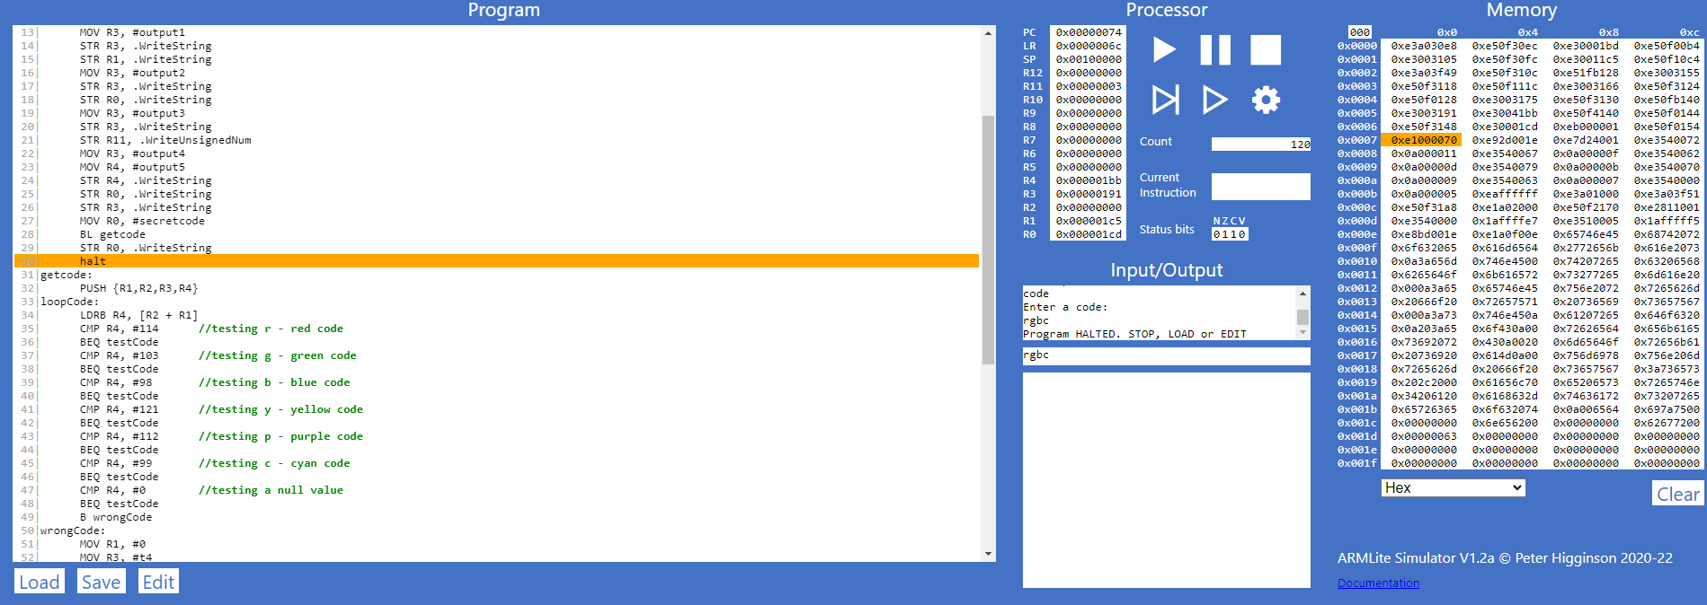

Stage 4:

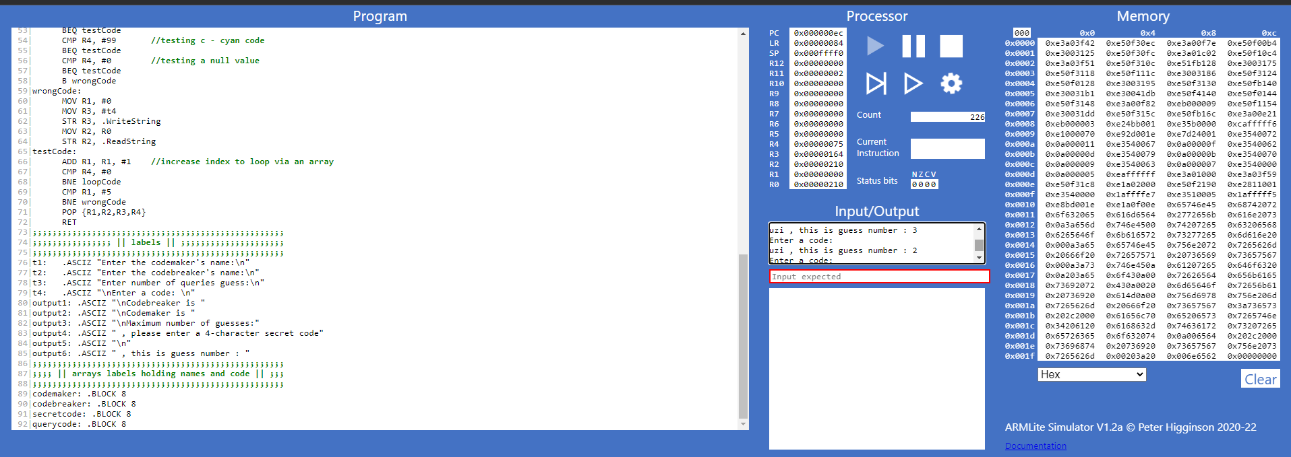

Stage 5:

a)

b)

